# In lab Task:`

**Code output:**

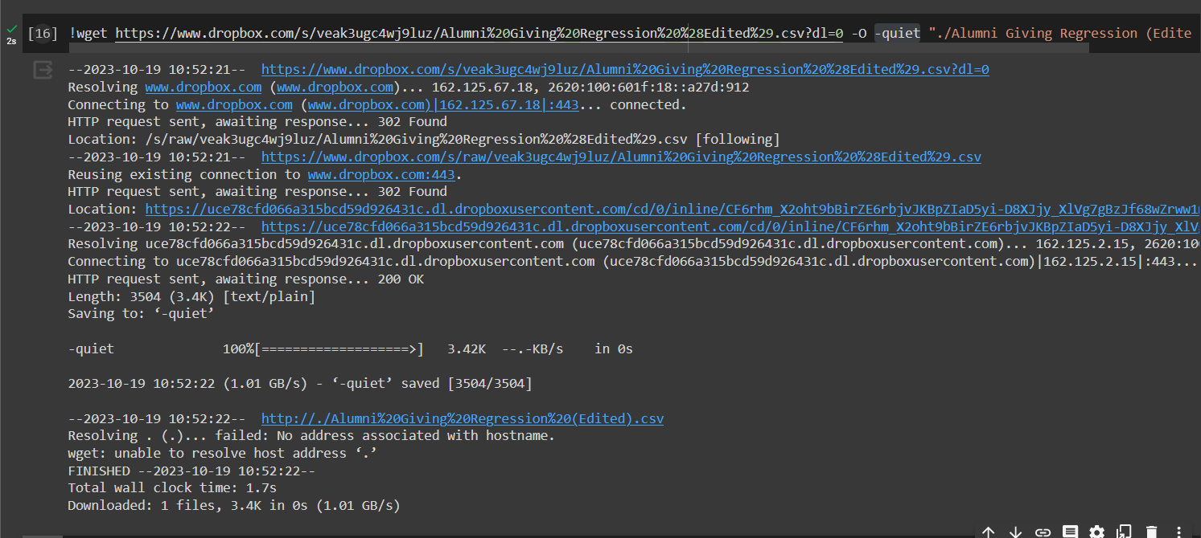

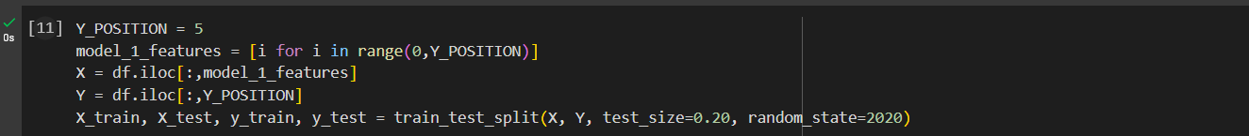

**Why Keras Sequential model?**

There are cases where deep learning models, including sequential models, can outperform classical machine learning methods like linear regression. These cases typically involve very large and complex datasets, and problems where the relationship between inputs and outputs is highly non-linear and difficult to model with traditional methods. Hence sequential model is not the best use for linear regression.

**What other models are available and what are their differences?**

**Traditional Machine Learning Models:**

1. **Sequential Model**: This is the simplest type of model in Keras, where you can stack layers sequentially. It's commonly used for feedforward neural networks.

**Pre-Trained Deep Learning Models:**

1. **VGG16 and VGG19**: Deep convolutional neural networks widely used for image classification tasks.
2. **ResNet**: Residual Networks are known for handling very deep architectures effectively. Variants include ResNet50, ResNet101, etc.
3. **InceptionV3**: Known for its performance on image classification tasks. It uses multiple parallel paths for processing images.

Sequential models in Keras allow for custom neural network architectures, enabling flexibility in design and training from scratch. They are versatile for various tasks. Pre-trained models, on the other hand, are pre-built architectures optimized for specific tasks like image classification. They're resource-intensive but excel in transfer learning, where they can be fine-tuned on new datasets. Primarily used for computer vision tasks, they offer powerful features for tasks like image classification and object detection. The choice depends on the specific task and resources available.